REGISTRATION FORM
for Participation in the Work of the
VII International Scientific and Technical Conference
"ABU ALI IBN SINO AND INNOVATIONS IN MODERN PHARMACEUTICS"
(March 18, 2024, Tashkent)
Full name:___________________________________
Organization (full and abbreviated name):__________
___________________________________________
Position:____________________________________
Academic degree and title:______________________
___________________________________________
Address for correspondence:____________________
___________________________________________
___________________________________________
Mob.:______________________________________
E-mail:_____________________________________
Title of presentation: __________________________
___________________________________________
___________________________________________
PARTICIPATION TYPE
- Plenary
- Oral
- Poster
- Publication
- Innovation Fair
- Young Scientist competition (under 30)
Date:_______________________________________
Signature:___________________________________
Abstracts will be issued in the Abstract book hard copy and in electron format
ABSTRACT SUBMISSION:
1. Volume - up to 2 full pages in A4 format; font - Times New Roman, font size 14; left indent - 3cm; on the right - 1.5 cm, above and below - 2 cm each, line spacing - 1.0.
2. The title of the thesis is written in capital letters in the middle. The next line contains the names and initials of the authors; scientific titles and positions are not indicated. On the next line, you should indicate the full name of the organization, city, country, full contact information (work and cell phones, e-mail addresses). It is necessary to underline the name of the speaker and send the completed participant registration form.
3. The file must include one work, the name of the file is given by the surname of the first author (for example, Botirov IM.docx).
4. Authors need to fully explain all abbreviations when they are first used in the text.
5. Materials are accepted in only in Uzbek or Russian and English.
The selection of incoming materials will be carried out by the editorial board. Materials that do not meet the requirements will not be considered by the organizing committee and will not be returned! The text must be verified and free of mistakes. The authors are responsible for the accuracy of the data and the scientific content of the work.

Submission of materials for participation in the Conference: it is necessary to fill out by March 1st, 2024 electronic registration form:
https://forms.gle/hsJs7FZ8fvhCM4TK6 with the obligatory attachment of abstracts in the MS Word format (*.docx).
Abstract submission deadline - till February 28, 2024 according to the above mentioned application form.
Ministry of Health of the Republic of Uzbekistan
Tashkent Pharmaceutical Institute
Ibn Sino Public Foundation
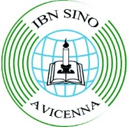
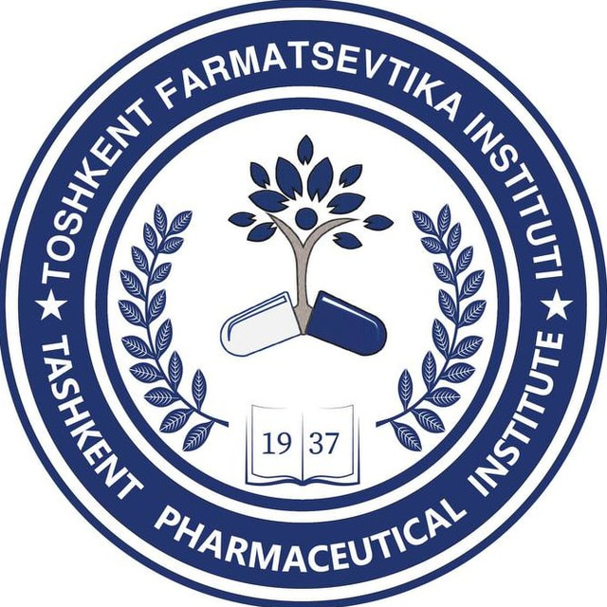
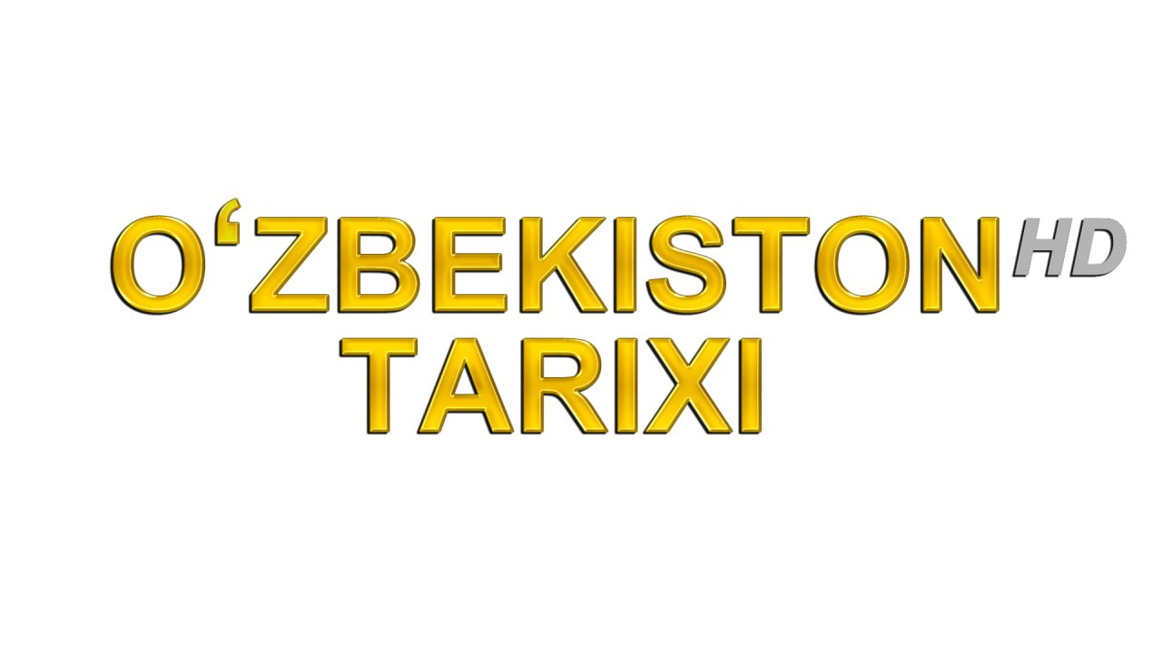
VII INTERNATIONAL
SCIENTIFIC AND TECHNICAL CONFERENCE
on
"ABU ALI IBN SINO AND INNOVATIONS IN MODERN PHARMACEUTICS"
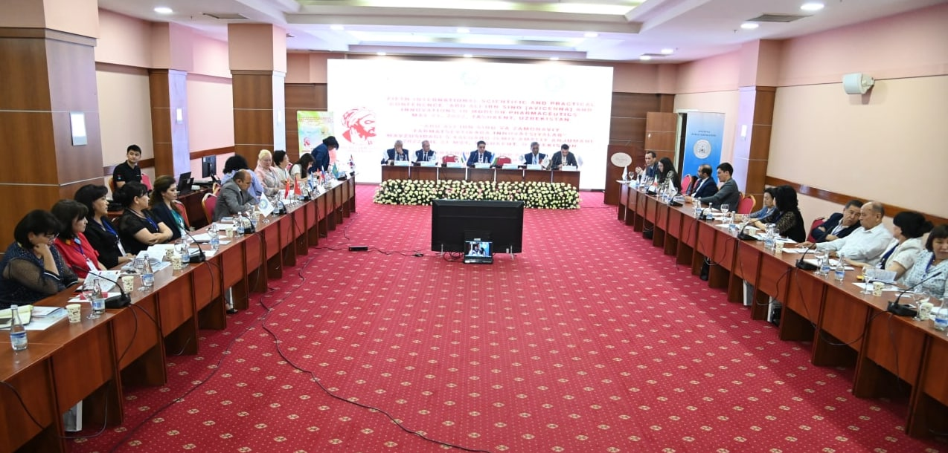
March 18, 2024, Tashkent
DEAR FRIENDS AND COLLEAGUES!

Ministry of Health of the Republic of Uzbekistan and the Tashkent Pharmaceutical Institute, together with the Ibn Sino Public Foundation cordially invite you to take part in the VII International Scientific and Practical Conference "ABU ALI IBN SINO AND INNOVATIONS IN MODERN PHARMACEUTICS", which will take place in Tashkent City on March 18, 2024

TOPICS OF THE CONFERENCE
1. Abu Ali Ibn Sino (Avicenna)'s contribution to the development of Pharmacy.
2. Reform of Pharmaceutical Education: successes, problems and prospects
3. Actual problems of industrial pharmacy
4. Marketing and Management in Pharmacy
5. Quality control, standardization and certification of medicines
6. Development of new drugs
7. Pharmacology and Clinical Pharmacy
8. Forensic and clinical toxicology

The Conference program includes plenary (20–30 min), oral (10 min) and poster presentations.
Conference languages: English (preferential), Uzbek and Russian

The abstracts will be selected in accordance with their relevance to the topics of the conference, material novelty, and deadline of sending the abstracts and registration form.
Authors will be noticed about the decision of the Organizing committee on abstract acceptance and further information

ORGANIZING COMMITTEE

Prof. Kamal Rizayev (Uzbekistan)
Nozimkhon Makhmudov (Uzbekistan)
Acad. Abbosxon Turayev (Uzbekistan)
Prof. Shomansur Sagdullayev (Uzbekistan)
Prof. Amina Ather (Germany)
Prof. Qodirjon Keskinbora (Turkie)
Assoc. Prof. Nodirali Normakhamatov (Uzbekistan)
PhD. Manzura Mulladzonova (Uzbekistan)
Prof. Flyura Urmanova (Uzbekistan)
Prof. Rustam Tulyaganov (Uzbekistan)
Prof. Ziyoda Faizieva (Uzbekistan)
Prof. Ekut Karieva (Uzbekistan)
PhD. Muxabbat Ibragimova (Uzbekistan)
Assoc. Prof. Firuza Maksudova (Uzbekistan)
Assoc.Prof.RayhonaKhusainova (Uzbekistan)
Assoc.Prof.Dilnoza Zulfikarieva (Uzbekistan)
Assoc. Prof. Gulnora Sultonova (Uzbekistan)
PhD. Dildora Pulatova (Uzbekistan)
PhD. Khasan Abdurakhmonov (Uzbekistan)
PhD. Iroda Shermatova (Uzbekistan)
MSc. Albina Abdulleva (Uzbekistan)

ABSTRACT SAMPLE

DETERMINATION OF THE ADSORPTION ABILITY OF A COMBINED ENTEROSORBENT
Radzhapova P.A., Ismailova M. G.

Tashkent Pharmaceutical Institute, Tashkent , Republic of Uzbekistan
e-mail: pharmi@pharmi.uz , tel . 256-39-54

Relevance:
Purpose of the study:
Materials and methods: ….
Results: ….
Conclusions: ….

CONTACT INFORMATION
Organizing Committee:
Tashkent Pharmaceutical Institute:
Aybek str., 45.Tashkent city, Uzbekistan
tel/fax: (+99871) -256-39-54

Mullazhonova Manzura Tokhirovna, Ph.D. in Pharmacy, Associate Professor (Head of the Department of Science)
Tel.: (99890) -374-04-01;
(99871)-256-39-54;

Come, participate, share your scientific ideas, join the cooperation!

